# Project Report

On

**KISAAN-NETRA**

**Innotech’20**

*Submitted by*

Naveen Garg (Roll No.:02814504418 )

Prateek Khanduri (RollNo.02814504418)

Sarthak Avlash (RollNo.03814504418)

*Under the guidance of:*

**Dr. Rekha Gupta**

*(Associate Professor (Sr.))*



## Lal Bahadur Shastri Institute of Management

**(LBSIM)**

**Dwarka, New Delhi**

**(2020)**

**CERTIFICATE**

**PROFORMA FOR CERTIFICATE FOR PROJECT**

This is to certify that this is a bonafide record of the project work done satisfactorily at **KISAAN-NETRA** by Group Members:

Mr. Sarthak Avlash

Mr. Naveen Garg

Mr. Prateek Khanduri

Enrollment No. 03414504418

Enrollment No. 02414504418

Enrollment No. 02814504418

This report or a similar report on the topic has not been submitted for any other project competition.

DATE: SIGNATURE OF PROJECT GUIDE

Name:

Designation:

**ACKNOWEDGEMENT**

We are thankful to our college LBSIM for considering our project and extending help at all stages needed during our work of collecting information regarding the project.

It gives us immense pleasure to express our deep and sincere gratitude to Assistant Professor **Dr. Rekha Gupta** (Project Guide) for her kind help and valuable advice during the development of project synopsis and for her guidance and suggestions.

We wish to express our profound thanks to all those who helped us in gathering information about the project. Our families too have provided moral support and encouragement at several times.

**Table of Contents**

|  |  |  |
| --- | --- | --- |
|  | **Topic** | **Page no.** |
|  | |  |
| 1. ABSTRACT | |  |
|  | |  |
| 1. SYNOPSIS | |  |
|  | |  |
| 1. REQUIREMENTS | |  |
| **3.1** | Software Requirements |  |
| **3.2**  **3.3** | Hardware Requirements  Technologies Used |  |
|  | |  |
| **4.** DETAILED ARCHITECTURE    **4.1** Use Case Diagram | |  |
| **4.2** | Activity Diagram |  |
| **4.3** | ER Diagram |  |
| **4.4** | DFD |  |
|  | |  |
| 1. IMPLEMENTATION METHODOLOGY | |  |
| **5.1** | Code |  |
| **5.2** | Storyboard |  |
|  | |  |
| 1. CONCLUSION AND FUTURE SCOPE | |  |
| **6.1** | Conclusion |  |
| **6.2** | Future Scope |  |
|  | REFERENCE |  |
|  | |  |

**ABSTRACT**

Agriculture uptil now is the backbone of our country’s economy and the credit for that goes entirely to the farmers. But majority of our farmers are not literate due to lack of education in rural areas and even though their traditional methods and estimations regarding farming have served well uptil now, they had certain downfalls as well.

So, in order to act as a third eye of farmer and ensuring that the farmer is aware of any and every kind of information regarding agriculture and healthy growth of crops, we have built this project.

In this we have developed a web portal using which we will be accessible to a certain group of experts of agriculture related fields who will be updating required information and we will be conveying that information provided to us to farmers via SMS Alerts (Text and Audio) on their mobile phones.

**SYNOPSIS**

# 1. Introduction

This project is aimed at providing weather advisory services to farmers based on the best available weather and climate information at their specific location to help improve the quality and quantity of food production in a sustainable manner.

Awareness of what the end user needs from a weather forecast and communicating it effectively is very important.

Although this project is for general use, but it is mainly being developed to aid the farmers in rural and remote areas of our country who does not have access to daily weather forecasts on television/radio.

Helping the farmers in terms of Crop suggestion, precautions based on the met department

orecast of rain fall/weather, potential pest attacks, weather warnings etc.

**2. Objective**

* Build a system that provides details to farmers on weather patterns that could impact the crop, possible pest attacks , and weather warnings by analysing old (from met department) and new data (inserted by experts).
* Notifying farmers concerning all the relevant information with respect to the weather and other pertinent issues such as excessive use of manures/fertilisers and hygiene and diet for farm animals.
* To send **SMS Alerts in Textual and Audio form** on Weather conditions and other advisory services regularly (day-to day) to farmers. SMS Alerts will be sent in **regional languages.** Also, the farmer can chat through a **ChatBot.**
* Experts (Weather, Crop, Consultant:- Agriculture Loan Advisor, Stock Advisor etc.) will guide the farmers regarding their respective expertise.

**REQUIREMENTS**

* 1. **Software Requirements:**
* PHP MyAdmin
* APPACHE HTTP SERVER

**3.2 Hardware Requirements:**

* Intel core i3 processor or equivalent or higher
* 4GB RAM or Higher
* 20GB HDD or Higher
* Network Connectivity

**3.3 Technologies Used:**

* **Front End** - HTML/CSS, JavaScript, Bootstrap
* **Back End** - PHP, MySQL

**DETAILED ARCHITECTURE**

**4.1 Use Case Diagram**

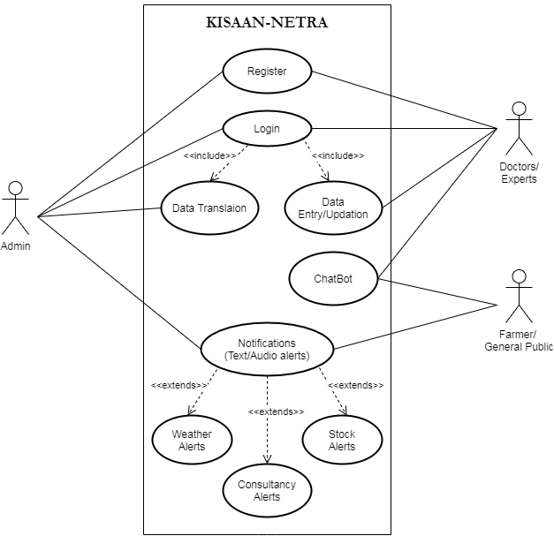

**Use Case Description:**

**Login**

|  |  |  |
| --- | --- | --- |
| **Use Case Name:** | Login | |
| **Scenario:** | User will login in the system. | |
| **Triggering Event:** | Registration is done or not. | |
| **Brief Description:** | User has to enter his/her Username and Password to log in to their respective portal. | |
| **Actors:** | Admin, Expert | |
| **Related Use Case:** | None | |
| **Stakeholders:** | None | |
| **Preconditions:** | There are no external stakeholders. | |
| **Post Conditions:** | There should be availability of a portal. | |
| **Flow of Activities:** | User   1. User enters the Username and password. 2. User logs in the system. | System   * 1. System will take the input. |
| **Exception Conditions:** | Registration is not done. | |

**Register**

|  |  |  |
| --- | --- | --- |
| **Use Case Name:** | Register | |
| **Scenario:** | User will register in the system. | |
| **Triggering Event:** | User is already registered or not. | |
| **Brief Description:** | Being a new user, the user has to register/Sign up in order to get their own unique Username and password allotted. | |
| **Actors:** | Admin, Expert | |
| **Related Use Case:** | None | |
| **Stakeholders:** | None | |
| **Preconditions:** | There are no external stakeholders. | |
| **Post Conditions:** | There should be a new user. | |
| **Flow of Activities:** | User   1. User provide the Email and password in the System. | System   * 1. System will take the input.   2. System saves information. |
| **Exception Conditions:** | E-mail already used for registration. | |

**Data Entry/Updation**

|  |  |  |
| --- | --- | --- |
| **Use Case Name:** | Data Entry/Updation. | |
| **Scenario:** | Expert will enter/update the data in his/her respective portal. | |
| **Triggering Event:** | Expert has logged in. | |
| **Brief Description:** | Expert after logging in will be redirected to their respective portal in order for them to update the required data. | |
| **Actors:** | Expert | |
| **Related Use Case:** | None | |
| **Stakeholders:** | None | |
| **Preconditions:** | There are no external stakeholders. | |
| **Post Conditions:** | Data should be updated. | |
| **Flow of Activities:** | User   1. Expert will enter/update   the data as defined in  screen. | System   1. System will save and update the data. |
| **Exception Conditions:** | No data to update. | |

**Data Translation**

|  |  |  |
| --- | --- | --- |
| **Use Case Name:** | Data Translation | |
| **Scenario:** | Admin will translate the data in Hindi. | |
| **Triggering Event:** | Admin will simplify the data. | |
| **Brief Description:** | Admin will simplify and translate the data provided by Experts for proper understanding of farmers. | |
| **Actors:** | Admin | |
| **Related Use Case:** | None | |
| **Stakeholders:** | None | |
| **Preconditions:** | There are no external stakeholders. | |
| **Post Conditions:** | Data will be ready to send to the farmer. | |
| **Flow of Activities:** | User   1. Admin receives the data   provided by experts.   1. Admin simplifies and translates the data. 2. Admin sends the information. | System   * 1. Admin views the details (Weather Report, Stock etc.).   2. The data is being translated. |
| **Exception Conditions:** | No data is updated. | |

**Chatbot**

|  |  |  |
| --- | --- | --- |
| **Use Case Name:** | Chatbot | |
| **Scenario:** | Experts and farmers will interact with each other. | |
| **Triggering Event:** | Farmer will consult an Expert regarding something. | |
| **Brief Description:** | An additional feature provided to farmer in case he wishes to interact directly with the Experts. | |
| **Actors:** | Farmer, Expert | |
| **Related Use Case:** | None | |
| **Stakeholders:** | None | |
| **Preconditions:** | There are no external stakeholders. | |
| **Post Conditions:** | Farmer has received the solution. | |
| **Flow of Activities:** | User  1.Farmer initiates the chat  with an issue.  2.Expert responds accordingly. | System   * 1. A pop-up is sent to respective Expert’s portal. |
| **Exception Conditions:** | Network connectivity is poor. | |

**Notification**

|  |  |  |
| --- | --- | --- |
| **Use Case Name:** | Notification | |
| **Scenario:** | SMS Alert/Notification will be sent on farmer’s mobile. | |
| **Triggering Event:** | Admin is done simplifying and translating the Expert’s data. | |
| **Brief Description:** | Admin after simplifying and translating the data in Hindi will send the respective data on farmer’s mobile in form of SMS Alerts (Text and Audio). | |
| **Actors:** | Admin, Farmer | |
| **Related Use Case:** | None | |
| **Stakeholders:** | None | |
| **Preconditions:** | There are no external stakeholders. | |
| **Post Conditions:** | Farmer has received the SMS Alert (Text and Audio). | |
| **Flow of Activities:** | User   1. Admin clicks on send message. 2. Admin receives notifications in case message is not dilevered. | System   * 1. System gathers information on farmer’s contact information.   2. System sends all the respective alerts(stock alerts, Consultancy alert, Weather alert) as text messages using textlocal API, . |
| **Exception Conditions:** | 1.1 Registered Mobile number is incorrect.  1.2 Admin receives notification message not send. | |

**4.2 Activity Diagram:**

* **Login Portal:**

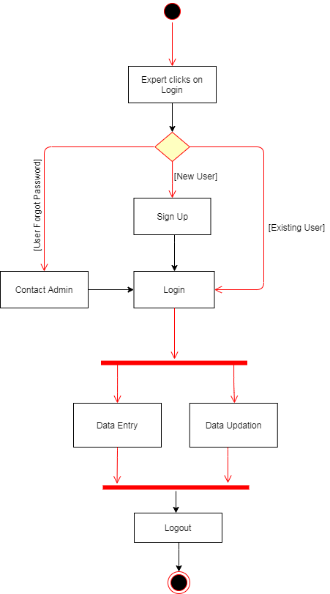

* **Chatbot Portal:**

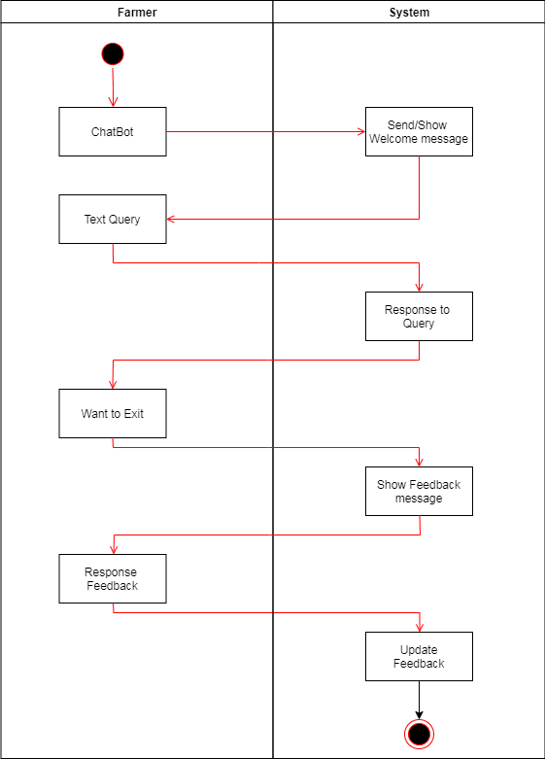

* **Notification:**

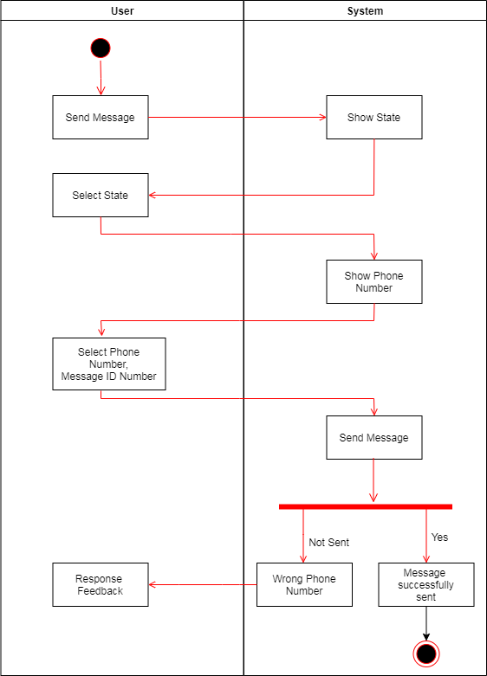

**4.3 ER Diagram:**

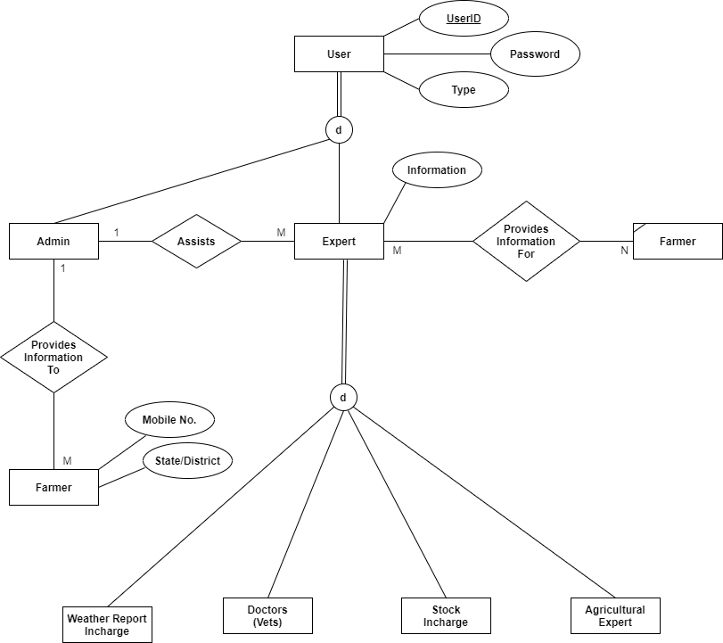

**4.4 Data Flow Diagram (DFD):**

* **Context Level**

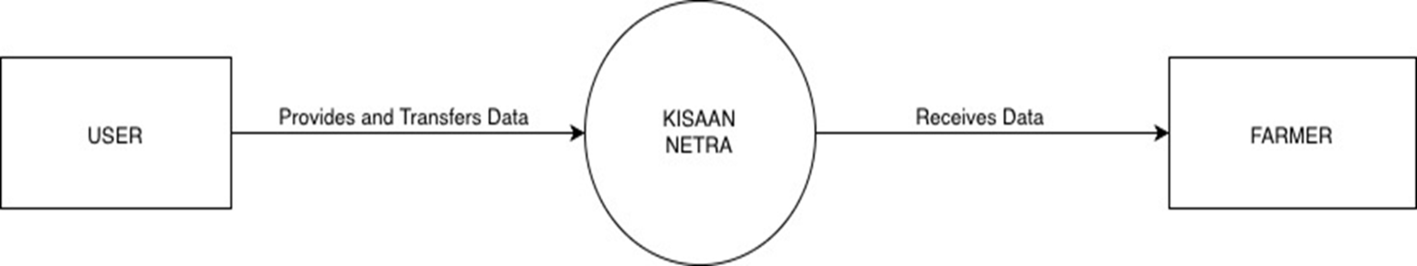

* **Level-1**

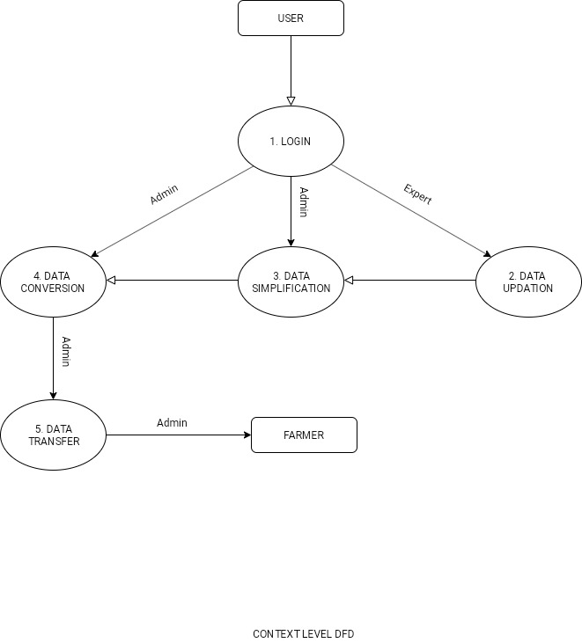

* **Level-2**

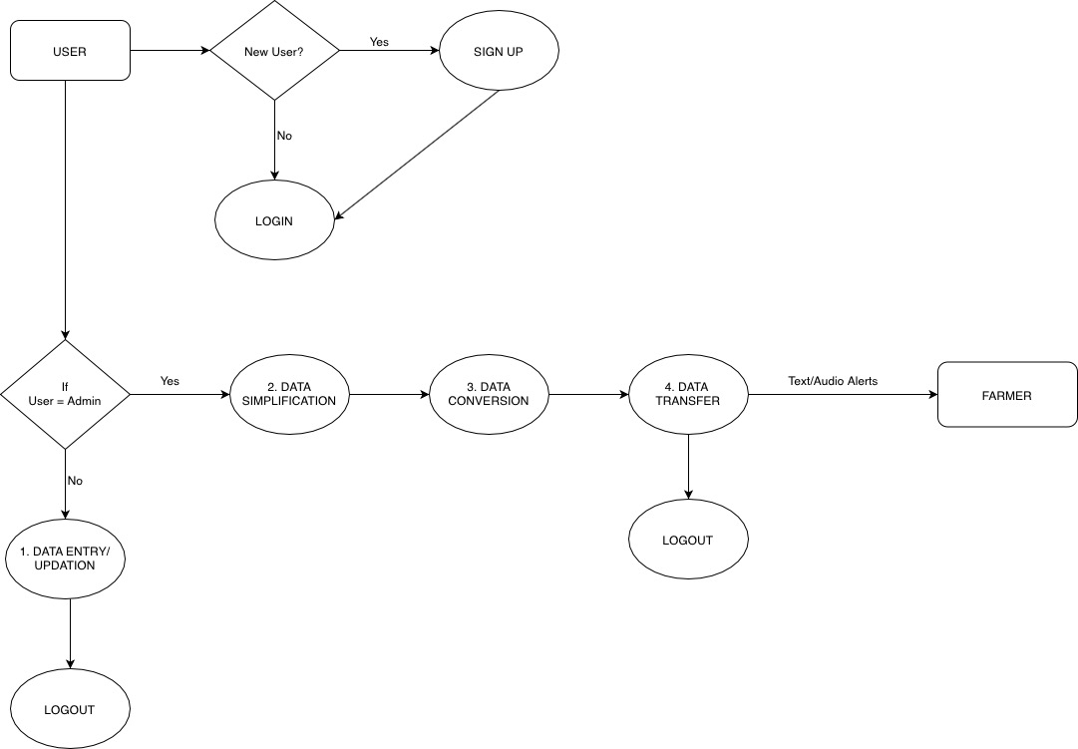

**IMPLEMENTATION METHODOLOGY**

**5.1 Code**

**Voice Message and Text Message API Code**

**<?php**

//Voice.php includes the code for Voice Messages.

if(isset($_POST['voice']))

{

require_once('voice.php');

}

**?>**

<br>

**<?php**

$DATABASE_HOST = 'sql212.freecluster.eu';

$DATABASE_USER = 'epiz_25041824';

$DATABASE_PASS = 'XEXxRwaCxjJDO';

$DATABASE_NAME = 'epiz_25041824_test';

/*

$DATABASE_HOST = 'localhost';

$DATABASE_USER = 'root';

$DATABASE_PASS = '';

$DATABASE_NAME = 'accounts';

*/

// Create connection

$conn = mysqli_connect($DATABASE_HOST, $DATABASE_USER, $DATABASE_PASS);

$db = mysqli_select_db($conn, $DATABASE_NAME);

require_once ('vendor/autoload.php');

use \Statickidz\GoogleTranslate;

$trans = new GoogleTranslate();

if (isset($_POST['search']))

{

$id = $_POST['id'];

$query = "SELECT * FROM expert_weather WHERE weather_id = '$id'";

$query_run = mysqli_query($conn, $query);

while ($rows = mysqli_fetch_array($query_run))

{

if(isset($_POST['search']))

{

// Authorisation details.

// Textlocal API used for text messages.

$username = "kisaannetra@gmail.com";

$hash = "50db1fde63dc0a74e6cdc5f5276295a06800d5fe27487f3c3ef5a08ed927a3eb";

$sender = "TXTLCL";

$unicode = "1";

// Config variables. Consult http://api.textlocal.in/docs for more info.

$test = "0";

// Data for text message. This is the text message data.

// This is who the message appears to be from.

$numbers = "+919711191064"; // A single number or a comma-seperated list of numbers

$a = "Today's temperature will be between " ;

$b = $rows['weather_temperature'];

$c = " Degrees! ";

$d = $rows['comment'];

$message = $a.$b.$c.$d;

$target = $_POST['target'];

$message = $trans->translate("en", $target, $message);

// 612 chars or less

// A single number or a comma-seperated list of numbers

$message = urlencode($message);

$data = "username=".$username."&hash=".$hash."&message=".$message."&sender=".$sender."&numbers=".$numbers."&test=".$test."&unicode=1";

//api.textlocal.in/send/?apikey=jxslui0FkGo-1rPMwGvOGQYWiLuU7r6fDxXBtUqJXP&sender=TXTLCL&numbers=919711191064&message=नमस्कार&unicode=1

$ch = curl_init('http://api.textlocal.in/send/?');

curl_setopt($ch, CURLOPT_POST, true);

curl_setopt($ch, CURLOPT_POSTFIELDS, $data);

curl_setopt($ch, CURLOPT_RETURNTRANSFER, true);

$result = curl_exec($ch); // This is the result from the API

curl_close($ch);

echo '<div class="notificacion">', $result,'</div>';

}

**?>**

<br> <br>

<tr>

<th>Weather_id</th>

<th>weather_temperature</th>

<th>State</th>

<th>Date</th>

<th>Status</th>

</tr>

<tr>

<td> **<?php** echo $rows['weather_id']; **?>**</td>

<td> **<?php** echo $rows['weather_temperature']; **?>**</td>

<td> **<?php** echo $rows['state']; **?>**</td>

<td> **<?php** echo $rows['date']; **?>**</td>

<td> Message Sent</td>

</tr>

**<?php**

}

}

**?>**

**Open Weather API Code**

**<?php**

//If statements for OpenWeather API (Experts will be given the data from their respective states.

if($State == "Andhra Pradesh")

    $cityId = "1278629";

if($State == "Arunachal Pradesh")

    $cityId = "1278341";

if($State == "Assam")

    $cityId = "1278253";

if($State == "Bihar")

    $cityId = "1275716";

if($State == "Chhattisgarh")

    $cityId = "1275634";

if($State == "Goa")

    $cityId = "1271157";

if($State == "Gujarat")

    $cityId = "1270770";

if($State == "Haryana")

    $cityId = "1270260";

if($State == "Himachal Pradesh")

    $cityId = "1270101";

if($State == "Jammu and Kashmir")

    $cityId = "1269320";

if($State == "Jharkhand")

    $cityId = "1444365";

if($State == "Karnataka")

    $cityId = "1267701";

if($State == "Kerala")

    $cityId = "1267254";

if($State == "Madhya Pradesh")

    $cityId = "1264542";

if($State == "Maharashtra")

    $cityId = "1264418";

if($State == "Manipur")

    $cityId = "1263706";

if($State == "Meghalaya")

    $cityId = "1263207";

if($State == "Mizoram")

    $cityId = "1262963";

if($State == "Nagaland")

    $cityId = "1266366";

if($State == "Orissa")

    $cityId = "1261029";

if($State == "Punjab")

    $cityId = "1259223";

if($State == "Rajasthan")

    $cityId = "1258899";

if($State == "Sikkim")

    $cityId = "1256312";

if($State == "Tamil Nadu")

    $cityId = "1255053";

if($State == "Telagana")

    $cityId = "1269844";

if($State == "Tripura")

    $cityId = "1254169";

if($State == "Uttaranchal")

    $cityId = "1444366";

if($State == "Uttar Pradesh")

    $cityId = "1253626";

if($State == "West Bengal")

    $cityId = "1252881";

if($State == "Andaman and Nicobar Islands")

    $cityId = "1278647";

if($State == "Chandigarh")

    $cityId = "1274746";

if($State == "Dadar and Nagar Haveli")

    $cityId = "1273726";

if($State == "Delhi")

    $cityId = "1261481";

if($State == "Ladakh")

    $cityId = "1267776";

if($State == "Lakshadeep")

    $cityId = "1267390";

if($State == "Pondicherry")

    $cityId = "1259424";

$apiKey = "0f454fd2d74825cef4c234b35f8bd206";

//$cityId = "1278629";

$googleApiUrl = "http://api.openweathermap.org/data/2.5/weather?id=" . $cityId . "&lang=en&units=metric&APPID=" . $apiKey;

$ch = curl_init();

curl_setopt($ch, CURLOPT_HEADER, 0);

curl_setopt($ch, CURLOPT_RETURNTRANSFER, 1);

curl_setopt($ch, CURLOPT_URL, $googleApiUrl);

curl_setopt($ch, CURLOPT_FOLLOWLOCATION, 1);

curl_setopt($ch, CURLOPT_VERBOSE, 0);

curl_setopt($ch, CURLOPT_SSL_VERIFYPEER, false);

$response = curl_exec($ch);

curl_close($ch);

$data = json_decode($response);

date_default_timezone_set('Asia/Kolkata');

$currentTime = time();

**?>**

<body> <div class="report-container">

<h3>**<?php** echo $data->name; **?>**: Weather Status</h3>

<div class="time">

<div>**<?php** echo date("l g:i a", $currentTime); **?>**</div>

<div>**<?php** echo date("jS F, Y",$currentTime); **?>**</div>

<div>**<?php** echo ucwords($data->weather[0]->description); **?>**</div>

</div>

<div class="weather-forecast">

<img

src="http://openweathermap.org/img/w/<?php echo $data->weather[0]->icon; ?>.png"

class="weather-icon" /> **<?php** echo $data->main->temp_max; **?>**°C (MAX), &nbsp<span

class="min-temperature">**<?php** echo $data->main->temp_min; **?>**°C (MIN) &nbsp</span>

</div>

<div class="time">

<div>Humidity: **<?php** echo $data->main->humidity; **?>** %</div>

<div>Wind: **<?php** echo $data->wind->speed; **?>** km/h</div>

</div>

</div>

</body>

**5.2 Storyboard**

1. 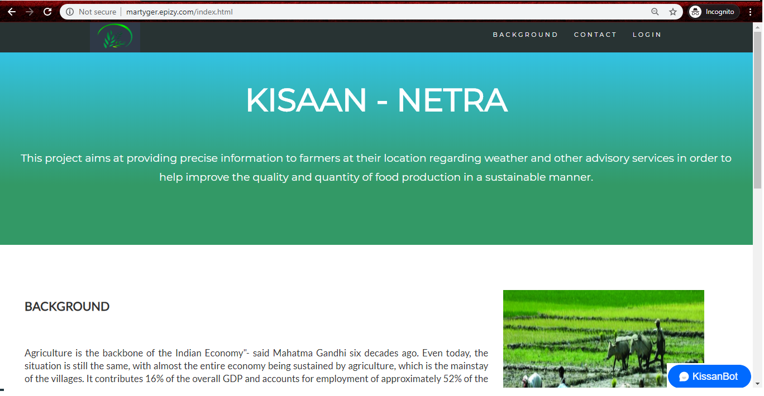**HOMEPAGE**
   1. 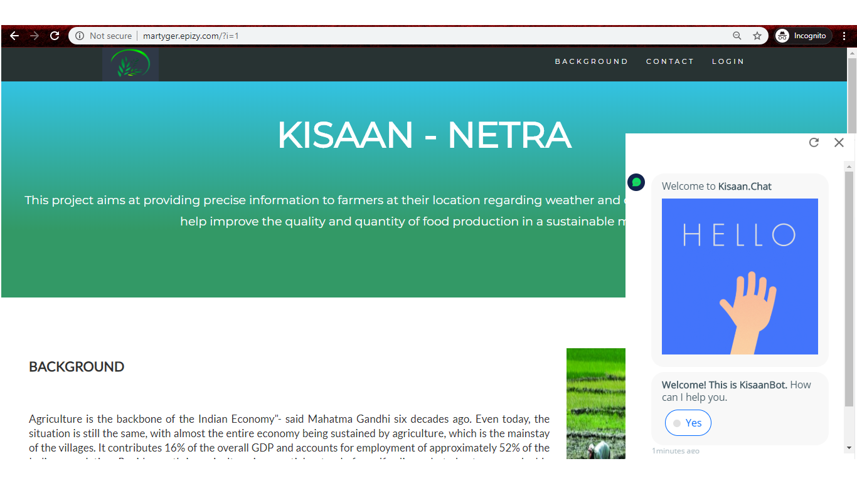**CHATBOT**
   2. 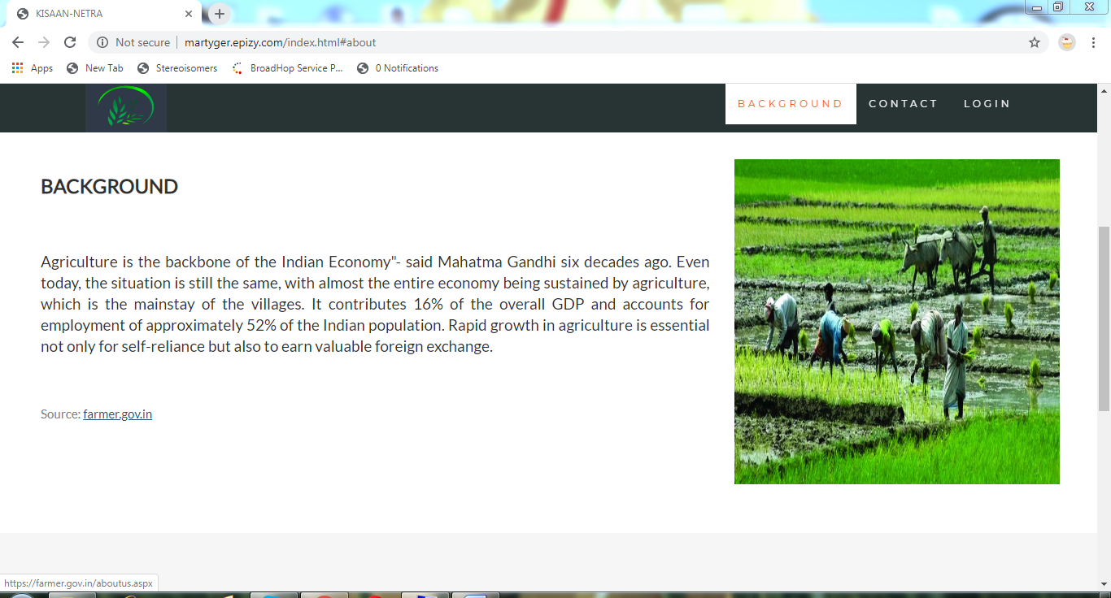**BACKGROUND**

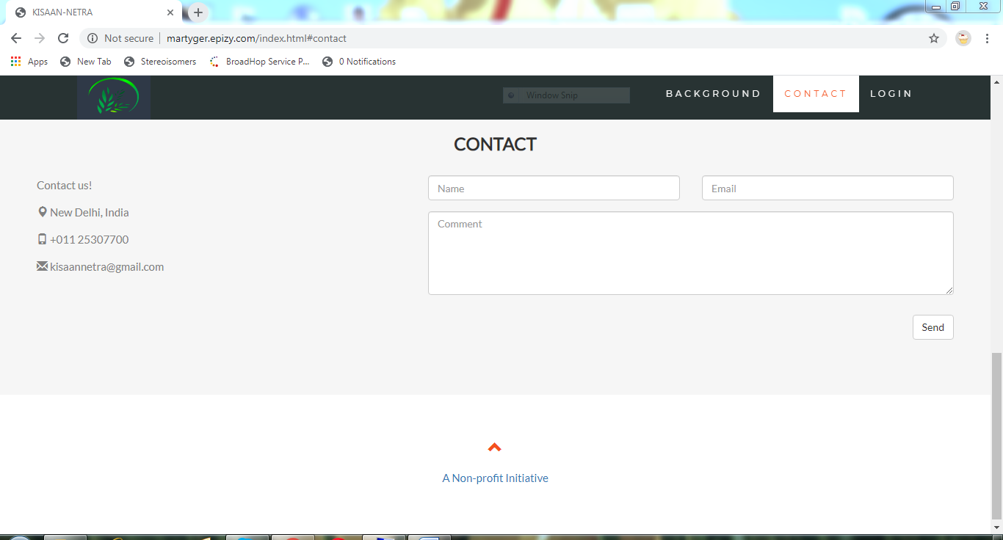**1.3 CONTACT**

* 1. 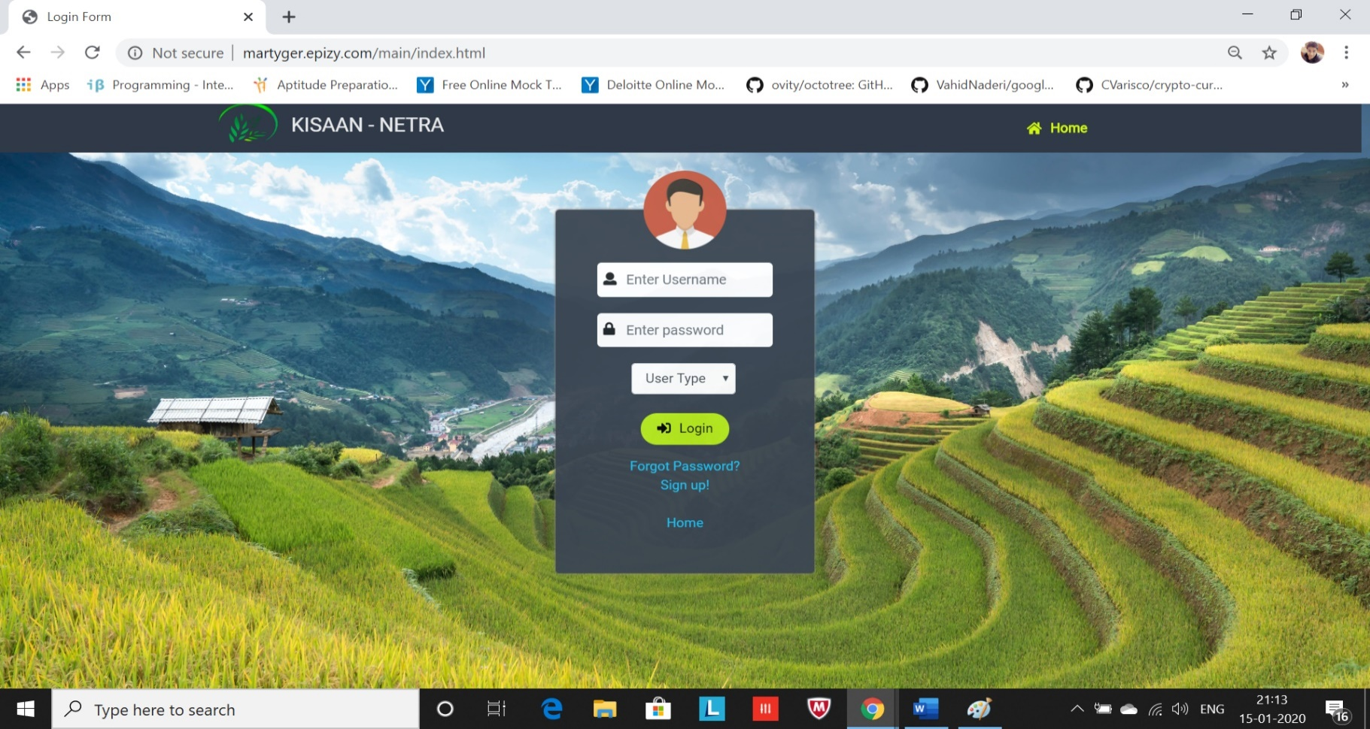**LOGIN PORTAL**

**2 IF USER IS NOT REGISTERED (SIGN UP PORTAL)**

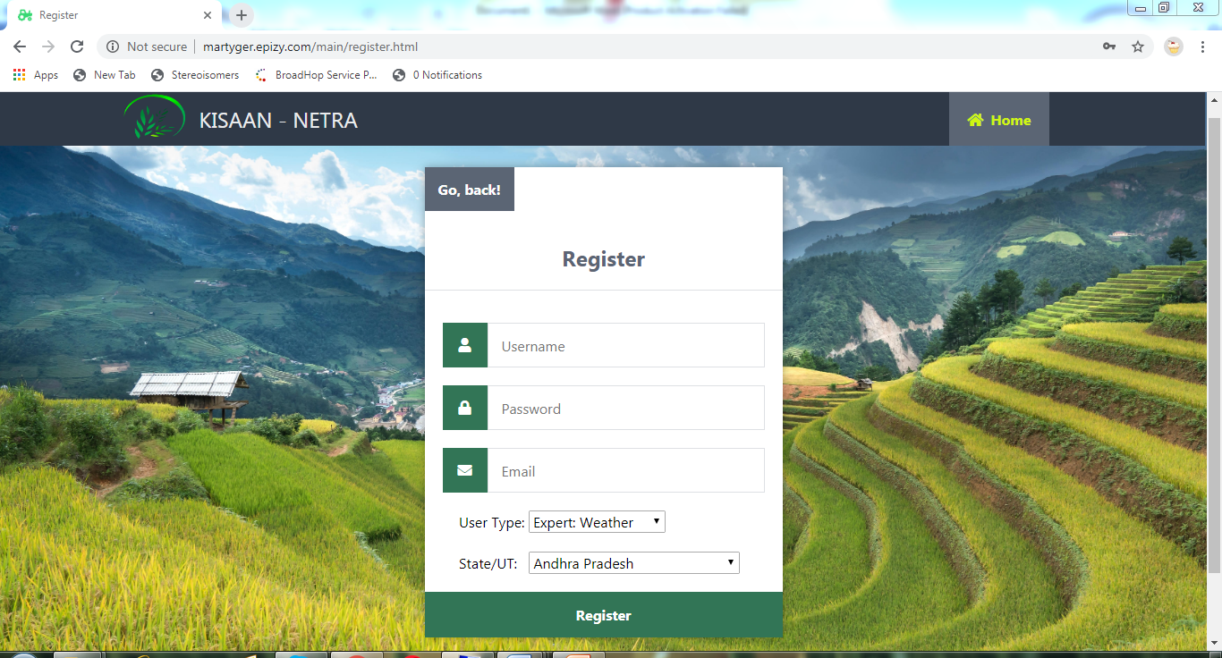

**2.1 IF USER FORGOT PASSWORD**

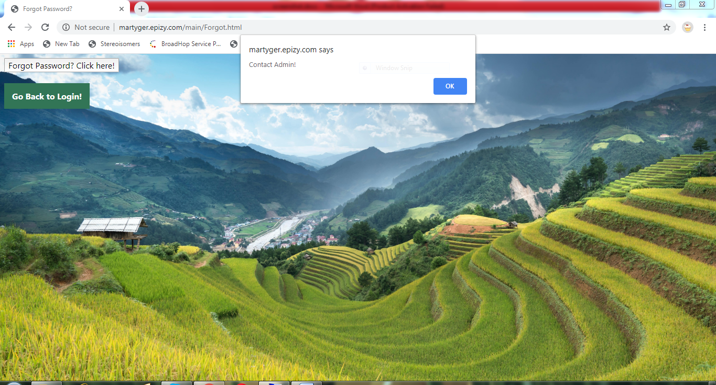

* 1. 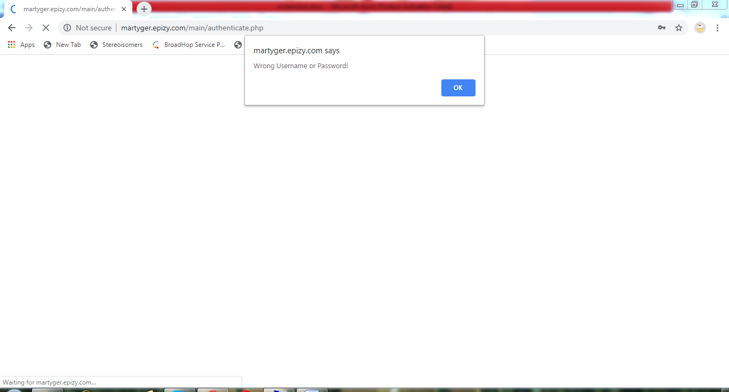**IF USER GIVES WRONG INPUT**

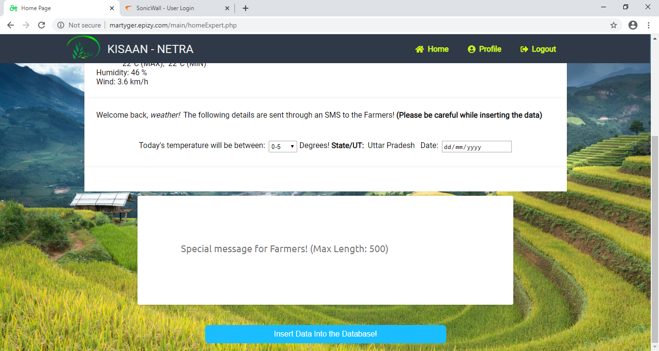**3 WHEN EXPERT LOGS IN (WEATHER EXPERT PORTAL)**

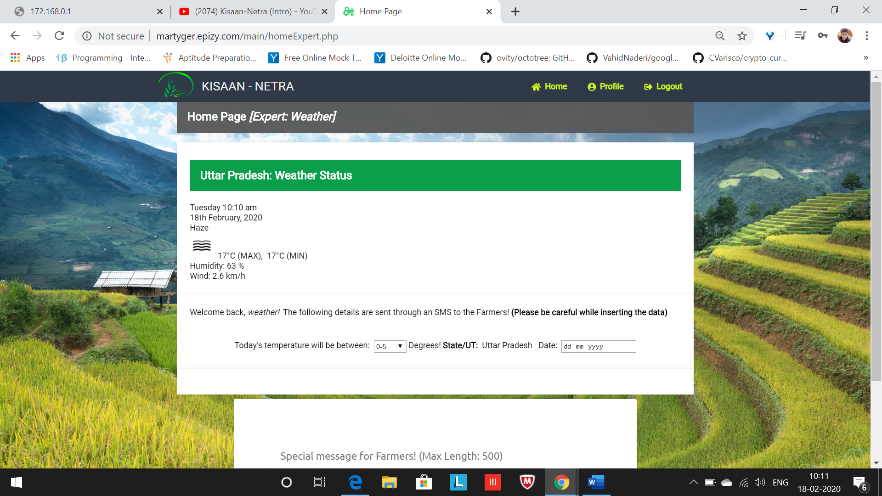**3.1 WHEN EXPERT LOGS IN (STOCK EXPERT PORTAL)**

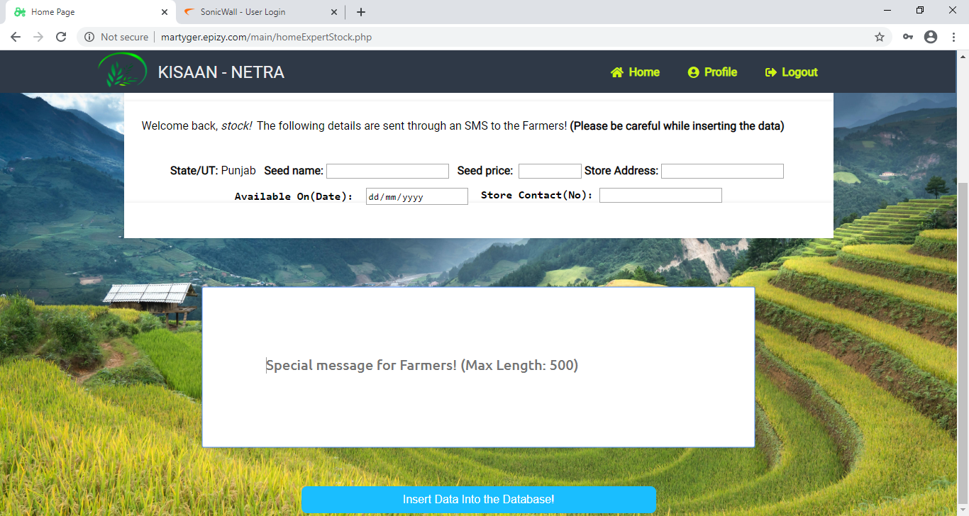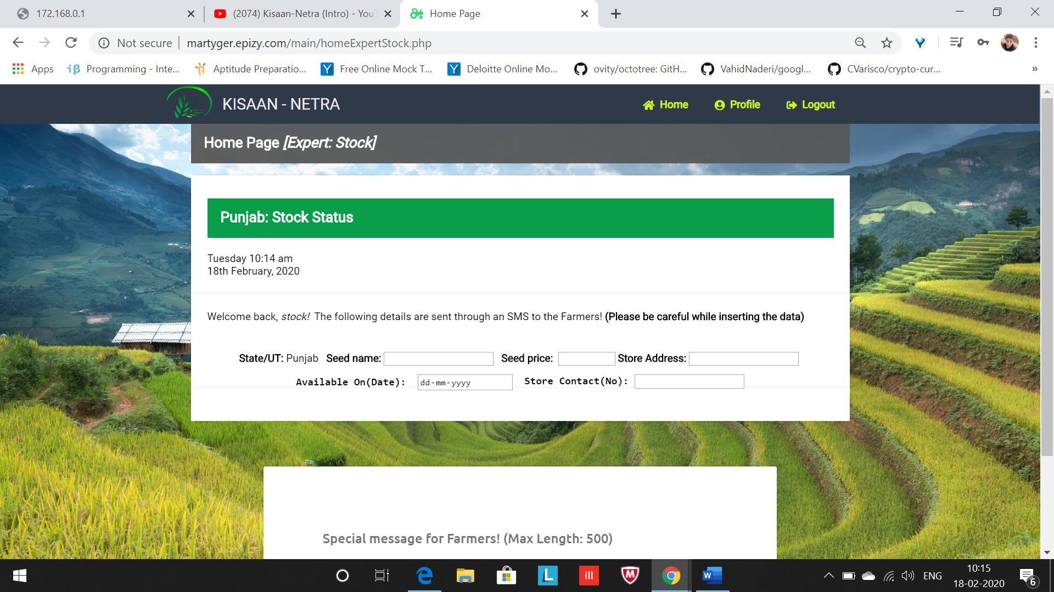

**3.2 WHEN EXPERT LOGS IN (CONSULTANT EXPERT PORTAL)**

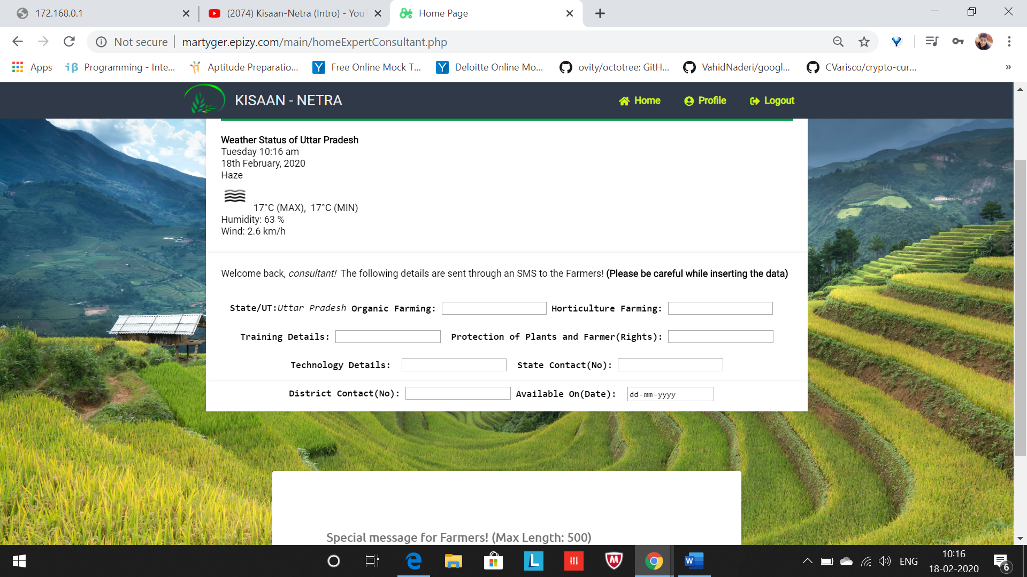

* 1. 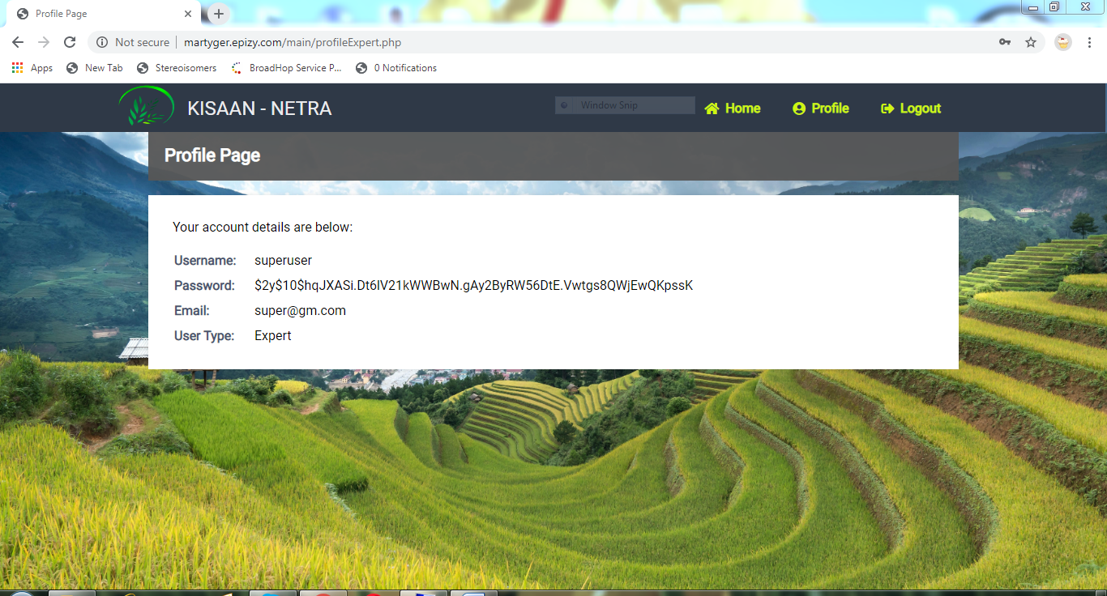**EXPERT’S PROFILE**

1. **WHEN ADMIN LOGS IN (ADMIN PORTAL)**

**4.1 ADMIN’S PROFILE**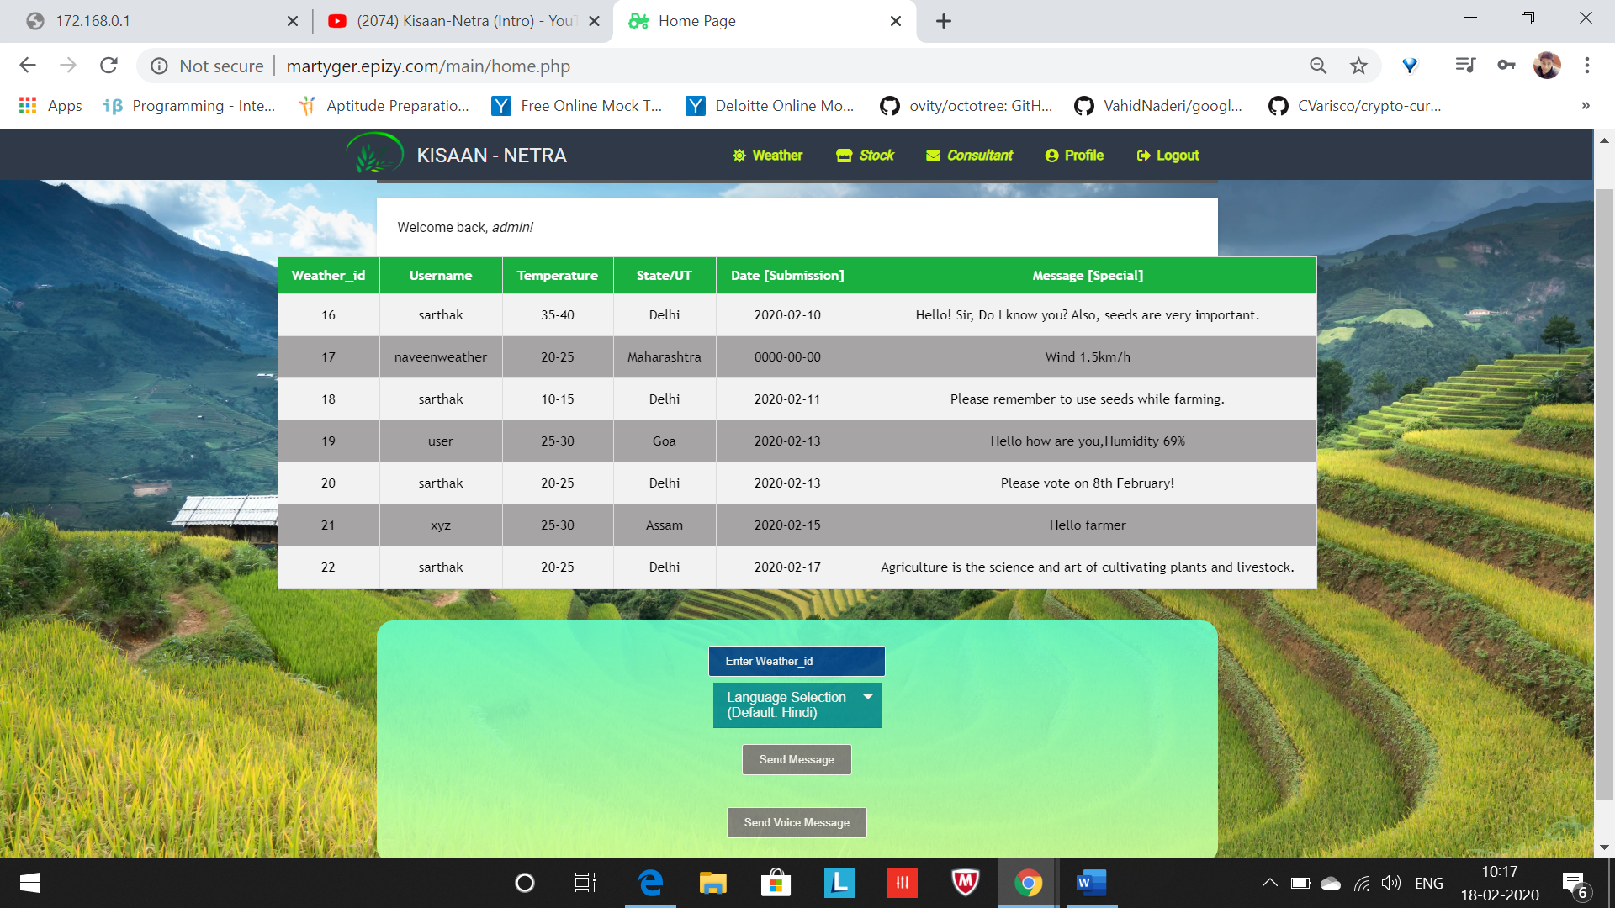

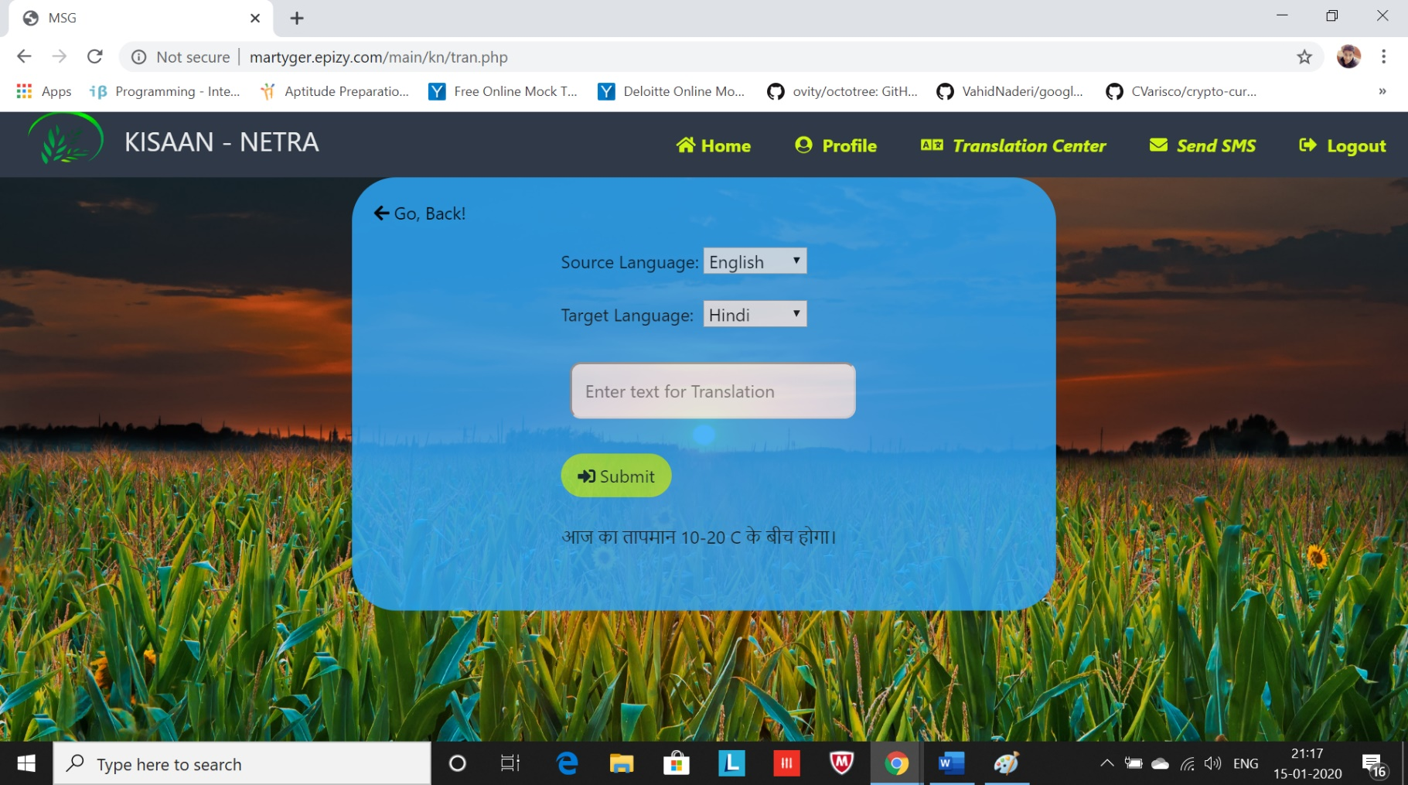**4.2 DATA CONVERSION BY ADMIN**

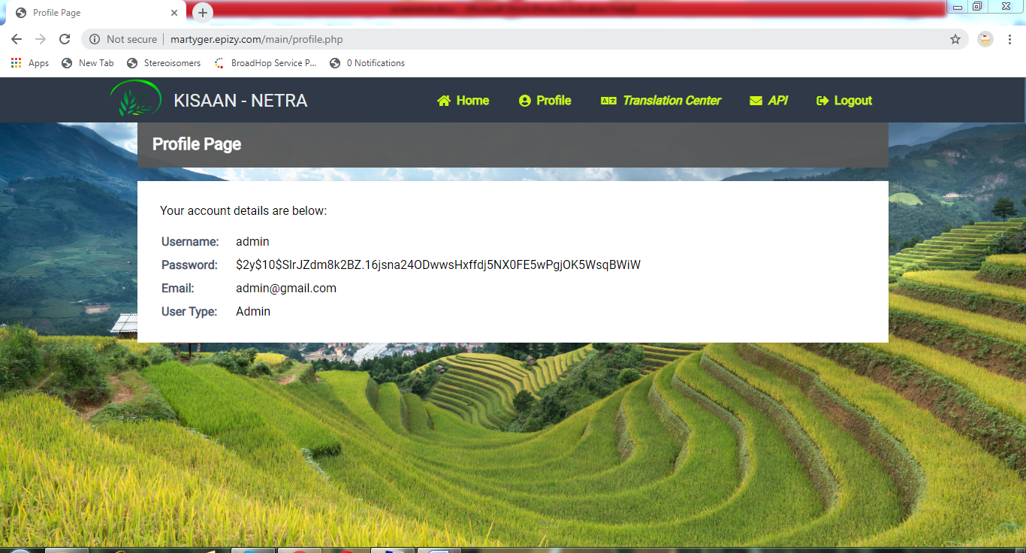**4.3 ADMIN PROFILE**

* 1. 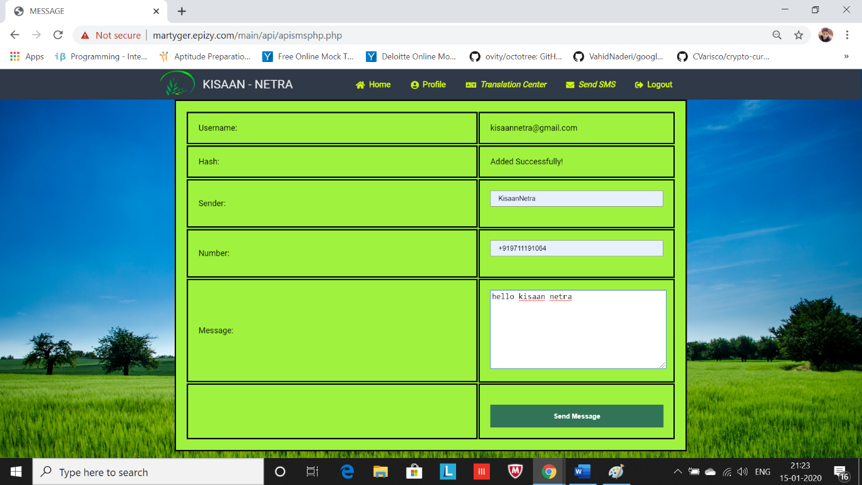**DATA TRANSFER BY ADMIN**

**5 DATA RECEIVED BY FARMER**

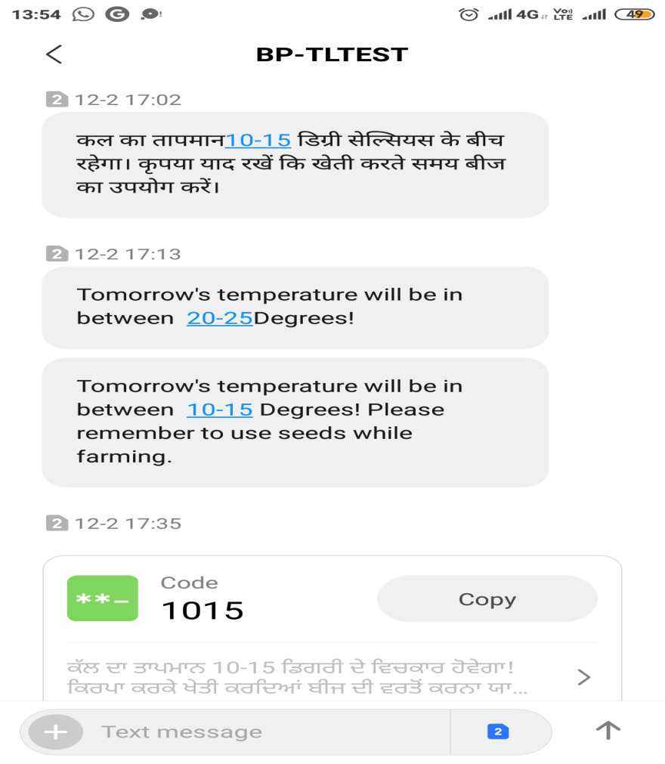

**CONCLUSION AND FUTURE SCOPE**

**Conclusion:**

By this project, we hope to act as a helping hand and contribute to the Agricultural growth as students by providing various information required by farmers and also providing solutions to them about queries proposed by them. This makes agriculture more ecofriendly and this portal is very useful to farmers.

And Great Experience for us to made this project efficiently and on estimate time. this project is only a humble venture to satisfy  the needs to manage the project work . several user friendly coding have also adopted .

The objective of software planning is to provide framework that enable to use to make reasonable estimates made within a limited time frame at the beginning of the software project and should be updated regularly as the project progresses.

**Future Scope:**

As of now we have only developed a small web portal with limited functionalities which is either due to lack of fundings or knowledge. We will be working on following areas to improve its efficiency:

* We will be designing a mobile app as well to make it more user-friendly
* A ChatBot feature will be provided in order to increase farmer’s participation, where farmer will directly communicate with Experts regarding any queries.
* Login access will be provided to farmers as well in the android app.

**REFERENCES**

[1] “City Weather”, [online] Available: http://www.imd.gov.in/pages/city_weather_main.php

[2] “Farmer’s Portal”, [online] Available: https://farmer.gov.in/

[3] “Weather API”, [online] Available: <https://openweathermap.org/api>

[4] ”Text Message API”, [online] Available: <https://www.textlocal.in/>

[5] “ Audio Call API”, [online] Available: <https://www.twilio.com/docs/usage/api>

[6] ”Data Translate” , [online] Available: <https://cloud.google.com/translate/docs>

[7] “Ministry of Agriculture and Farmers’ Welfare”, [online] Available: <http://agriculture.gov.in/>

[8] ”PM-Kisan Samman Nidhi”, [online] Available: <https://www.pmkisan.gov.in/>